Accuracy and Precision of the Hand-Held MAVIS Wound Measurement Device

Plassmann P, Jones CD
University of Glamorgan, Faculty of Advanced Technology, Dept. of Computing and Mathematical Sciences, Pontypridd, Mid Glamorgan, CF37 1DL, www.MedImaging.org

McCarthy M
Dept. of Engineering Measurement, National Physical Laboratory, Teddington, Middlesex, UK, TW11 0LW, www.npl.co.uk

Abstract
Chronic skin wounds such as leg ulcers affect many people and can take a long time to heal. By measuring the physical dimensions of wounds clinicians receive feedback about the success of a selected treatment approach. For this feedback to be fast and reliable the wound measurement technique has to be precise and accurate.
This paper investigates the performance of a new hand-held, non-contact, wound measurement device based on stereo-photogrammetry. A set of twelve precision engineered volumetric artifacts is used for calibration of the instrument and as a performance benchmark. Results demonstrate that the standard deviation (which is used as a measure for precision) of area measurements is generally less than 1.5% of the respective area. For volume measurements the standard deviation is less than 4% and for circumference measurements it is less than 3% of the respective value.
The absolute accuracy error is under ±0.5 cm² for all area measurements and to under ±0.5 cm³ for all volume measurements. All circumference measurements were accurate to within ±0.2 cm. These results compare favourably with existing measurement techniques.

Introduction
The management of chronic wounds such as those found in diabetic feet or leg ulcers is placing an increasing burden on health service systems [1]. Although the underlying aetiology of a chronic wound is usually known to the wound healing specialist there is a wide variety of treatment regimes available [2]. Even for skilled and experienced practitioners the only reliable way of establishing if a wound is responding to a chosen treatment is often to objectively measure the wound size. Chronic wounds, however, have an unfortunate tendency of healing very slowly. Months or years rather than days or weeks are common for the healing process. Any measurement technique used for the purpose of establishing healing progress therefore has to be very precise in order to capture small changes in a wound's dimensions.

The current ‘gold standard’ for area measurement is the practice of tracing the perimeter of a wound through a double layer of a flexible transparent sheet material [3]. While the layer in contact with the wounds is discarded, the upper layer with the tracing is then measured by either placing it on metric graph paper, planimeters or by a second round of tracing using a digitising tablet [4]. This contact making method can be painful to the patient and may risk infection. In practice the use of unsuitably thick or exhausted marker pens and the high degree of dexterity required by the clinician performing the tracing significantly reduce the theoretical precision of the method [5] and errors up to 25% have been reported [6].
Several attempts have therefore been made to replace the data capture phase by digital photography or video, which has the advantage of avoiding contact with the patient [7,8]. Wound pictures are usually measured on a computer screen where they can also be enlarged so that the tracing process is freed from time restrictions and physical demands. Although area measurements produced this way tend to be more precise than those obtained by transparency tracings the method depends on the photography skills of the clinician who has to combine a frame-filling wound picture together with a reference scale in a single image taken perpendicular to the wound site. Results are only correct if the underlying assumptions that wound and reference scale are at the same distance to the camera and that the wound site itself flat are met [9].

Wounds with a significant volume have a tendency of healing first from their base before decreasing in area. At early healing stages the area might actually increase although the volume is decreasing. By just making area measurement, earlier stages of the healing process may therefore be missed or mis-represented. The current gold standard for volume measurements is the practice of filling the wound with a paste like material based on alginates or silicone [10]. These pastes usually set to a flexible and non-sticking cast within a few minutes so that they can removed from the wound and measured by either using a water displacement approach or, if the density of the material is controlled, by weighing them on precision scales. The precision of the method depends on the manual dexterity of the clinician applying the paste who has to shape the outside of the cast into a form that resembles the original healthy skin surface as closely as possible while the paste is in the process of setting.
An alternative approach is the practice of covering the wound with a layer of self-adhesive transparent sheet material and to measure the amount of saline required to fill the cavity between the wound bed and the film using a calibrated syringe [11]. Due to the tendency of wounds to absorb saline and the difficulty of producing the right amount of curvature in the covering sheet material this method is not only less accurate than the cast method but also significantly less hygienic as the contaminated saline may spill out when the film is removed.

In the past a number of attempts have therefore been made to design and build wound measurement instruments that are non-contact, precise and user friendly. Amongst these were laser scanners [12], structured light based instruments [1,13] and stereo-photogrammetric devices [14, 15]. These were either user-friendly but not very precise or precise but relatively cumbersome and difficult to use instruments.
Based on recent advantages in digital imaging hardware and stereo-photogrammetry software the authors have now produced a new instrument that combines the advantages of the best traditional approaches (non-contact, light-weight, mobile, visual record, easy to use, fully volumetric) with high precision and accuracy. This paper focuses on the calibration of this instrument and its resulting precision (defined as repeatability) and accuracy (defined as offset / bias).

The Instrument
Instrument description
The MAVIS design (an acronym for Measurement of Area and Volume Instrument System) is based on the principle of stereo-photogrammetry where two laterally displaced images of an observed object are recorded. The amount of lateral displacement of a given point in an observed object or scene is a direct measure for the distance between that point and the camera's focal point. Figure 1 shows the instrument assembly, which consists of 4 main components:
- A good quality SLR camera with a resolution of over 6 mega-pixels delivered by low noise imaging array with high dynamic resolution.
- A simple, non-dedicated flash with a linearly polarising filter incorporated into its housing
- A stereo lens adapter that produces the two laterally displaced images via a set of mirrors. The adapter is equipped with another polarising filter orientated at an 90 degrees angle with respect to the filter in the flash. This combination minimises specular reflections.
- A targeting aid for the user is provided by a dual light point projector at the base of the unit. The projector produces two beams of light that intersect at the centre of the middle of the field of view and in halfway in the field of depth (approximately 80 cm in front of the camera).

Taking Images
The instrument is about 1kg in weight and powered only by batteries to make it safe and highly portable. All photography parameters (distance, exposure time, ISO equivalent setting, etc.) are pre-set so that the instrument is ready to take images in a few seconds as soon as the flash is fully charged. The user activates the targeting projector, aligns both its light beams in the middle of the wound to be measured to ensure that the wound is centred in the image and taken within a tolerance distance of ±15 cm. After ensuring that the projector beam spots are as circular as possible (if they are elliptical the instrument's orientation towards the wound is not perpendicular, which may result in decreased accuracy and precision of measurements) the user releases the camera's trigger to capture a stereo wound image.
On a typical 128MB compact flash (CF) memory card the camera can store approximately 80 stereo images.

Making Measurements
The images are transferred from the to a PC of Laptop by the MAVIS measurement program, which automatically recognises the presence of the camera’s CF card in the computer’s adapter slot and starts the downloading process. Aided by an image pan and zoom facility users can then start to measure individual stereo images by delineating the perimeter of wounds using the computer's mouse. The remainder of the measurement process is fully automatic and results in a fully rendered 3-D map and representation of the wound site as shown in figure 2 with the following measurement data available for storage in the software's patient and wound data base:
- the 3-D representation of the wound
- the true wound surface area (in contrast to the projected area in traditional photographic wound measurement techniques)
- the true circumference of the wound (again in contrast to the projected perimeter provided by planar 2D photography)
- the volume of the wound
The volume of the wound is not “true” as a plausible definition of “true” is difficult to achieve. In past approaches wound volume has often been defined as the space enclosed between the measured wound bed and a hypothetical reconstructed surface, which was thought to resemble the original skin surface. While this definition is sensible for wound sites such as a relatively small leg ulcer it breaks down when trying to measure wound sites located, for example, at diabetic feet where entire toes have been amputated. The authors have therefore decided to drop the notion of “true” in favour of “repeatable” wound volume. This repeatable volume is defined as the space enclosed between the wound bed and a minimum surface supported by the perimeter of the wound as shown in figure 2(c). The minimum surface can be envisaged as a piece of virtual flexible rubber material that is pinned into place at the wound's perimeter. Apart from being computationally more robust and producing more repeatable results than surface reconstruction approaches this definition has the added advantage that protruding or overgranulating tissue inside the wound can not produce 'negative volume'.

Experimental Method
Calibration Artifacts
Figure 3 shows a set of 12 calibration artifacts produced by the UK's National Physical Laboratory (NPL) within a ‘Measurement for Innovators’ project sponsored by the UK Government Department of Trade and Industry. These artifacts were produced to tight tolerance limits and for a sample dimension were validated using a high precision 3D stage measurement machine at the NPL. The 95% confidence limit (approximately 2 standard deviations) in the accuracy of all three parameters, area, volume and circumference, of the artifacts is less than 1%.

Minimising Parameters Affecting Measurements
In order to establish the underlying measurement performance of the instrument itself it was necessary to eliminate any user interference from the processes of image capture and delineation. For image capture the instrument was therefore mounted in a photography stand exactly perpendicular and at constant distance to the artifacts. Ambient lighting was virtually zero in order to minimise any effects potentially arising from varying lighting situations. For the same reason images were always taken at the very moment the red indicator light of the flash signaled that the unit had reached a certain charge voltage.
In order to eliminate the user's influence on the delineation process the calibration artifacts were designed in such a way that a ring of blue anodised aluminium marks the circumference of each depression as shown in figure 3. The measurement software is capable of identifying the blue rings in the stereo images and automatically applies the appropriate delineations.

Precision Measurement Results
Each of the 12 artifacts was photographed and automatically measured 10 times. The standard deviations of each set of 10 measurements provide a measure for the precision (repeatability) of measurements and are plotted in the graphs of figure 4. As expected from previous studies [16] the precision of all measurements decreases as the respective dimensions become smaller. In practice this is not a problem as small wounds (less than approximately 1cm³ in volume with an area of less than 5cm²) have already progressed significantly and can be expected to heal quickly.
All artifacts were then photographed again 10 times each but this time manually and under poor conditions (varying ambient light, random flash charges times, instrument hand held by untrained volunteers after only 2 minutes of minimum instructions) in order to assess the influence of human operators on the image capture process. The delineation process was kept automatic because it is unrealistic to assume that manual delineation of clearly defined artifacts provides useful information on the instrument’s performance.
No surprisingly the deliberately flawed photographic technique added a certain amount of imprecision. For area measurements an additional 0.25% could be observed, while volume and circumference precision decreased by about 1%. Individual results are represented by circular data points in the scatter plots of figure 4. Note that the outlier of 9% standard deviation in the volume measurement results was caused by a single image where the automated delineation mechanism failed due to poor photographic technique.

Accuracy Measurement Results
Figure 5 shows the 6 artifacts selected from the set of 12 for initial accuracy measurements. The dimensions of these artifacts are located on the perimeter of the area/volume scatter plot shown in figure 4 that represents wound dimensions found in practice.
The mean of measurements was plotted against the known dimensions in the scatter plots shown figure 6(a). A least square error 2nd order polynomial fit was applied to the data in order to derive correction equations to the measurements, which were subsequently integrated into the measurement software. The validity of these correction equations was tested by repeating the measurement cycle on the remaining 6 control artifacts. The results shown in figure 6(b) demonstrate that the correction equations could significantly reduce the accuracy error to under ±0.5 cm² for all area measurements and to under ±0.5 cm³ for all volume measurements. All circumference measurements were accurate within ±0.2 cm.
The least square error 2nd order polynomial fit was applied again on the full set of 12 measurements and the near-horizontal orientation of the fitted line confirmed the assumption that the results on the initial subset of 6 calibration artifacts were representative for the whole set.

Discussion

Precision
It is important to note that the precision achieved on artifacts define the underlying performance of the instrument system. This performance cannot be matched in clinical practice due to the need for manual delineation of the wound boundary.

Previous studies [17] on a sample of 250 area measurements, for example, have shown that the manual delineation process in digital images adds on average between 1.5% (for large wounds with well defined boundaries) and slightly less than 5% (for small wounds with ill defined boundaries) to the underlying system standard deviation. As a result the combined precision of area measurements is expected to be in the range between 2% for well defined wounds with an area greater than 5 cm² and 8% for small wounds (<5 cm²) with poorly defined boundaries. The top graph in figure 7 shows that this precision compares favourably with other wound measurement techniques matching that of classical 2D photographic techniques. It should be noted, however, that measurements based on photography quantify the projection of the curved wound surface onto a plane.
Wounds located in flexible tissue (e.g. pilonidal sinus excisions or abdominal wounds) can change their appearance with the patient’s position, which in 2D techniques can produce drastically different results with the deformation of the wound’s aperture. As MAVIS calculates the true exposed surface area rather than the projected area the resulting measurements are significantly more reliable for this type of wound.

For volume measurements the manual delineation process is less of a problem provided the wound has indeed a volume of a few cm³. In these cases the majority of the wound volume is usually located around the center of the wound whereas the boundary area tends to be shallow thus adding relatively little to the overall value. In these cases the combined precision of volume measurements can be expected to be in the range between 2% for wounds with an area greater than 3 cm³ and 6% for those less than that. For very shallow wounds the additional error resulting from delineation inconsistencies is in the same region as the one found for wound areas. This produces a range of standard deviations between 4% for wounds with an area greater than 3 cm³ and 9% for those with a smaller volume. The bottom graph in figure 7 demonstrates that this precision is equivalent to that achieved by other 3D (laser and structured light) scanners.

Circumference measurement results are most sensitive to inconsistent manual delineations. For an operator that carefully follows every minute undulation along the wound’s boundary the resulting circumference line will be significantly longer than for an operator who delineated more ‘generously’ using longer straight sections. Although area and volume measurements can be quite similar for both approaches circumference measurements will differ considerably. Research is currently underway to assess the influence of a post-processing step that enforces a pre defined ‘stiffness’ onto the boundary line, which eliminates finer delineation details.

Accuracy
To the best of the author’s knowledge no accuracy data have been published to date for any particular wound measurement technique. This is probably due to the lack of a reliable set of volumetric artifacts that could be used as benchmarks. In clinical practice it is also less important to know the absolute value of a particular measurement. It is the relative change of wound dimensions over time that provides feedback on treatment success to the clinician. If, however, measurements are not only precise but also accurate any changes in wound dimensions will also be reflected accurately.

Conclusion
The MAVIS system produces measurement results that are comparable to those achieved using the best high quality laser scanning devices. In contrast to those devices the instrument is significantly easier to use and faster as no scan is required. The instrument does not expose any risks associated with laser technology and, with a weight of just over 1kg, is highly portable. By using standard off-the-shelf components such as a consumer grade SLR camera and flash the instrument is several times less expensive than a comparable laser scanner. The use of the instrument can be learned in a few minutes (as demonstrated in one of the experiments) and no special background in photography is required. In collaboration with several clinical collaborators the authors have now completed a software package that is tailored to the requirements of clinicians. The package facilitates the measurement of a wound image in less than 5 minutes and stores the 3D data, photograph, tracing curve, and measurement results in a patient database which allows users to plot progress graphs and export results to standard MS Office™ packages. The current status of the MAVIS project is available on www.MedImagin.org/Mavis.

Acknowledgements
The authors thankfully acknowledge the support of the UK Government Dept. for Trade and Industry ) within the framework of a ‘Measurement for Innovators’ project that enabled the production of the calibration artifacts used in this study. We also wish to thank Mr. Theo Frisch and Mr. Chris Schwake for producing and analysing 120 artifact images.

References

- Krouskop TA, Baker R, Wilson MS., 2002, A non contact wound measurement system, J Rehabil Res Dev, 39, 337-346
- Graumlich JF, Blough LS, McLaughlin RG, Milbrandt JC, Calderon CL, Agha SA, Scheibel LW, 2003, Healing pressure ulcers with collagen or hydrocolloid: a randomized, controlled trial, J Am Geriatr Soc, 51, 147-154
- Keast DH, Bowering CK, Evans AW, Mackean GL, BurrowsC, D'Souza L, 2004, MEASURE: A proposed assessment framework for developing best practice recommendations for wound assessment Wound Repair and Regeneration, 12, s1-s17
- Thawer HA, Houghton PE, Woodbury MG, Keast D, Campbell K, 2002, A comparison of computer-assisted and manual wound size measurement, Ostomy Wound Management, 48, 46-53
- Lagan KM, Dusoir AE, McDonough SM, Baxter GD, 2000, Wound measurement: the comparative reliability of direct versus photographic tracings analyzed by planimetry versus digitizing techniques Arch Phys Med Rehabil, 81, 1110-1116
- Bulstrode CJK, Goode AW, Scott PJ, 1986, Stereophotogrammetry for measuring rates for cutaneous healing: a comparison with conventional techniques, Clinical Sci, 71, 437-443
- Smith DJ, Bhat S and Bulgrin JP, 1992, Video image analysis of wound repair, Wounds, 4, 6-15
- Stacey MC, Burnand KG, Layer GT, Pattison M, Browse NL, 1991, Measurement of the healing of venous ulcers, Aust N Z J Surg, 61, 844-848
- Solomon C, Munro AR, Van Rij AM, Christie R, 1995, The use of video image analysis for the measurement of venous ulcers, Br J Dermatol, 133, 565-570
- Stotts NA, Salazar MJ, Wipke-Tevis D, McAdo E, 1996, Accuracy of alginate molds for measuring wound volumes when prepared and stored under varying conditions, Wounds: A compendium of clinical research and practice, 8, 5, 159-164
- Berg W, Traneroth C, Gunnarsson A, Lossing C, 1990, A method for measuring pressure sores, Lancet, 335, 1445-1446
- Ibbett DA, Dugdale RE, Hart GC, Vowden KR, Vowden P, 1994, Measuring leg ulcers using a laser displacement sensor, Physiol Meas, 15, 325-332
- Plassmann P, Jones B F, Ring EFJ, 1995, A Structured Light System for Measuring Wounds, The Photogrammetric Record, 15, 197-204
- Langemo DK, Melland H, Olson B, Hanson D, Hunter S, Henly SJ, Thompson P, 2001, Comparison of 2 wound volume measurement methods, Adv Skin Wound Care, 14, 190-196
- Boersma SM, van den Heuvel FA, Cohen AF, Scholtens REM, 2000, Photogrammetric Wound Measurement with a Three-Camera Vision System, Proceedings of the XIXth Congress of International Archives of Photogrammetry & Remote Sensing Amsterdam, Netherlands, 84-91
- Plassmann P, Jones TD, MAVIS: a non-invasive instrument to measure area and volume of wounds, 1998, Medical Engineering and Physics, 20, 5, 332-338
- Plassmann P, Jones TD, Improved active contour models with application to the measurement of leg ulcers, 2003, Electronic Imaging, 12, 2, 317-326

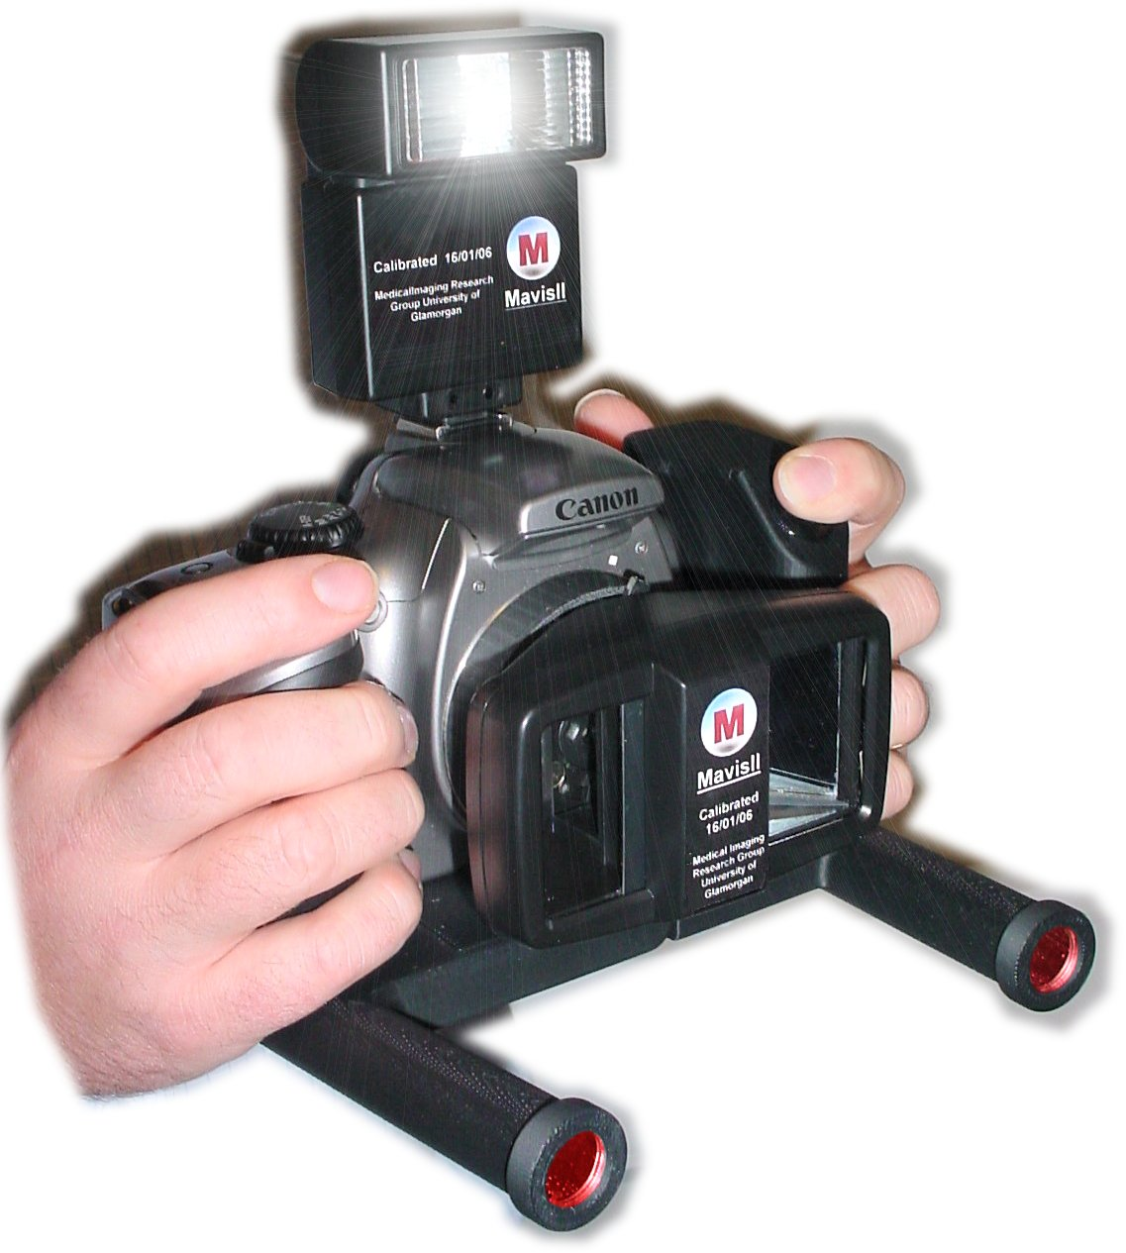
. Figure 1: The MAVIS instrument: camera, flash, 3D lens and dual light point projector:

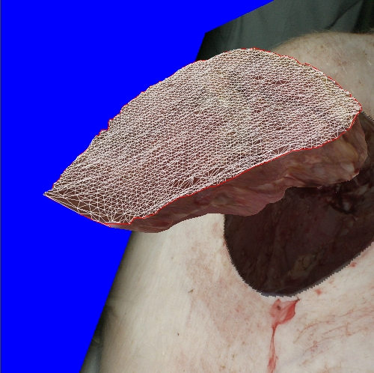
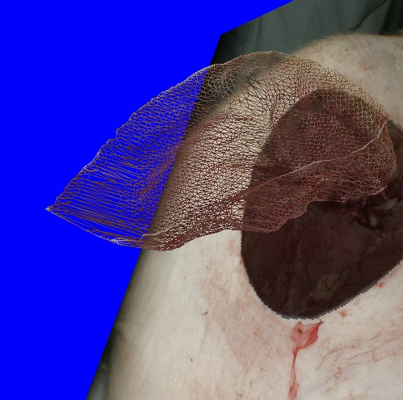
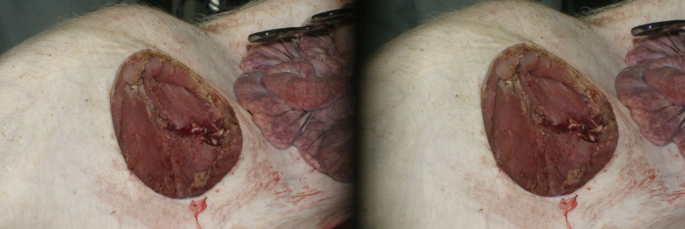
(b) (c)

Figure 2: Example of a 3D measurement: (a) original stereo image, (b) wire-mesh representation of the 3D map calculated from originals, (c) minimum surface mesh enclosing the wound volume
(a)

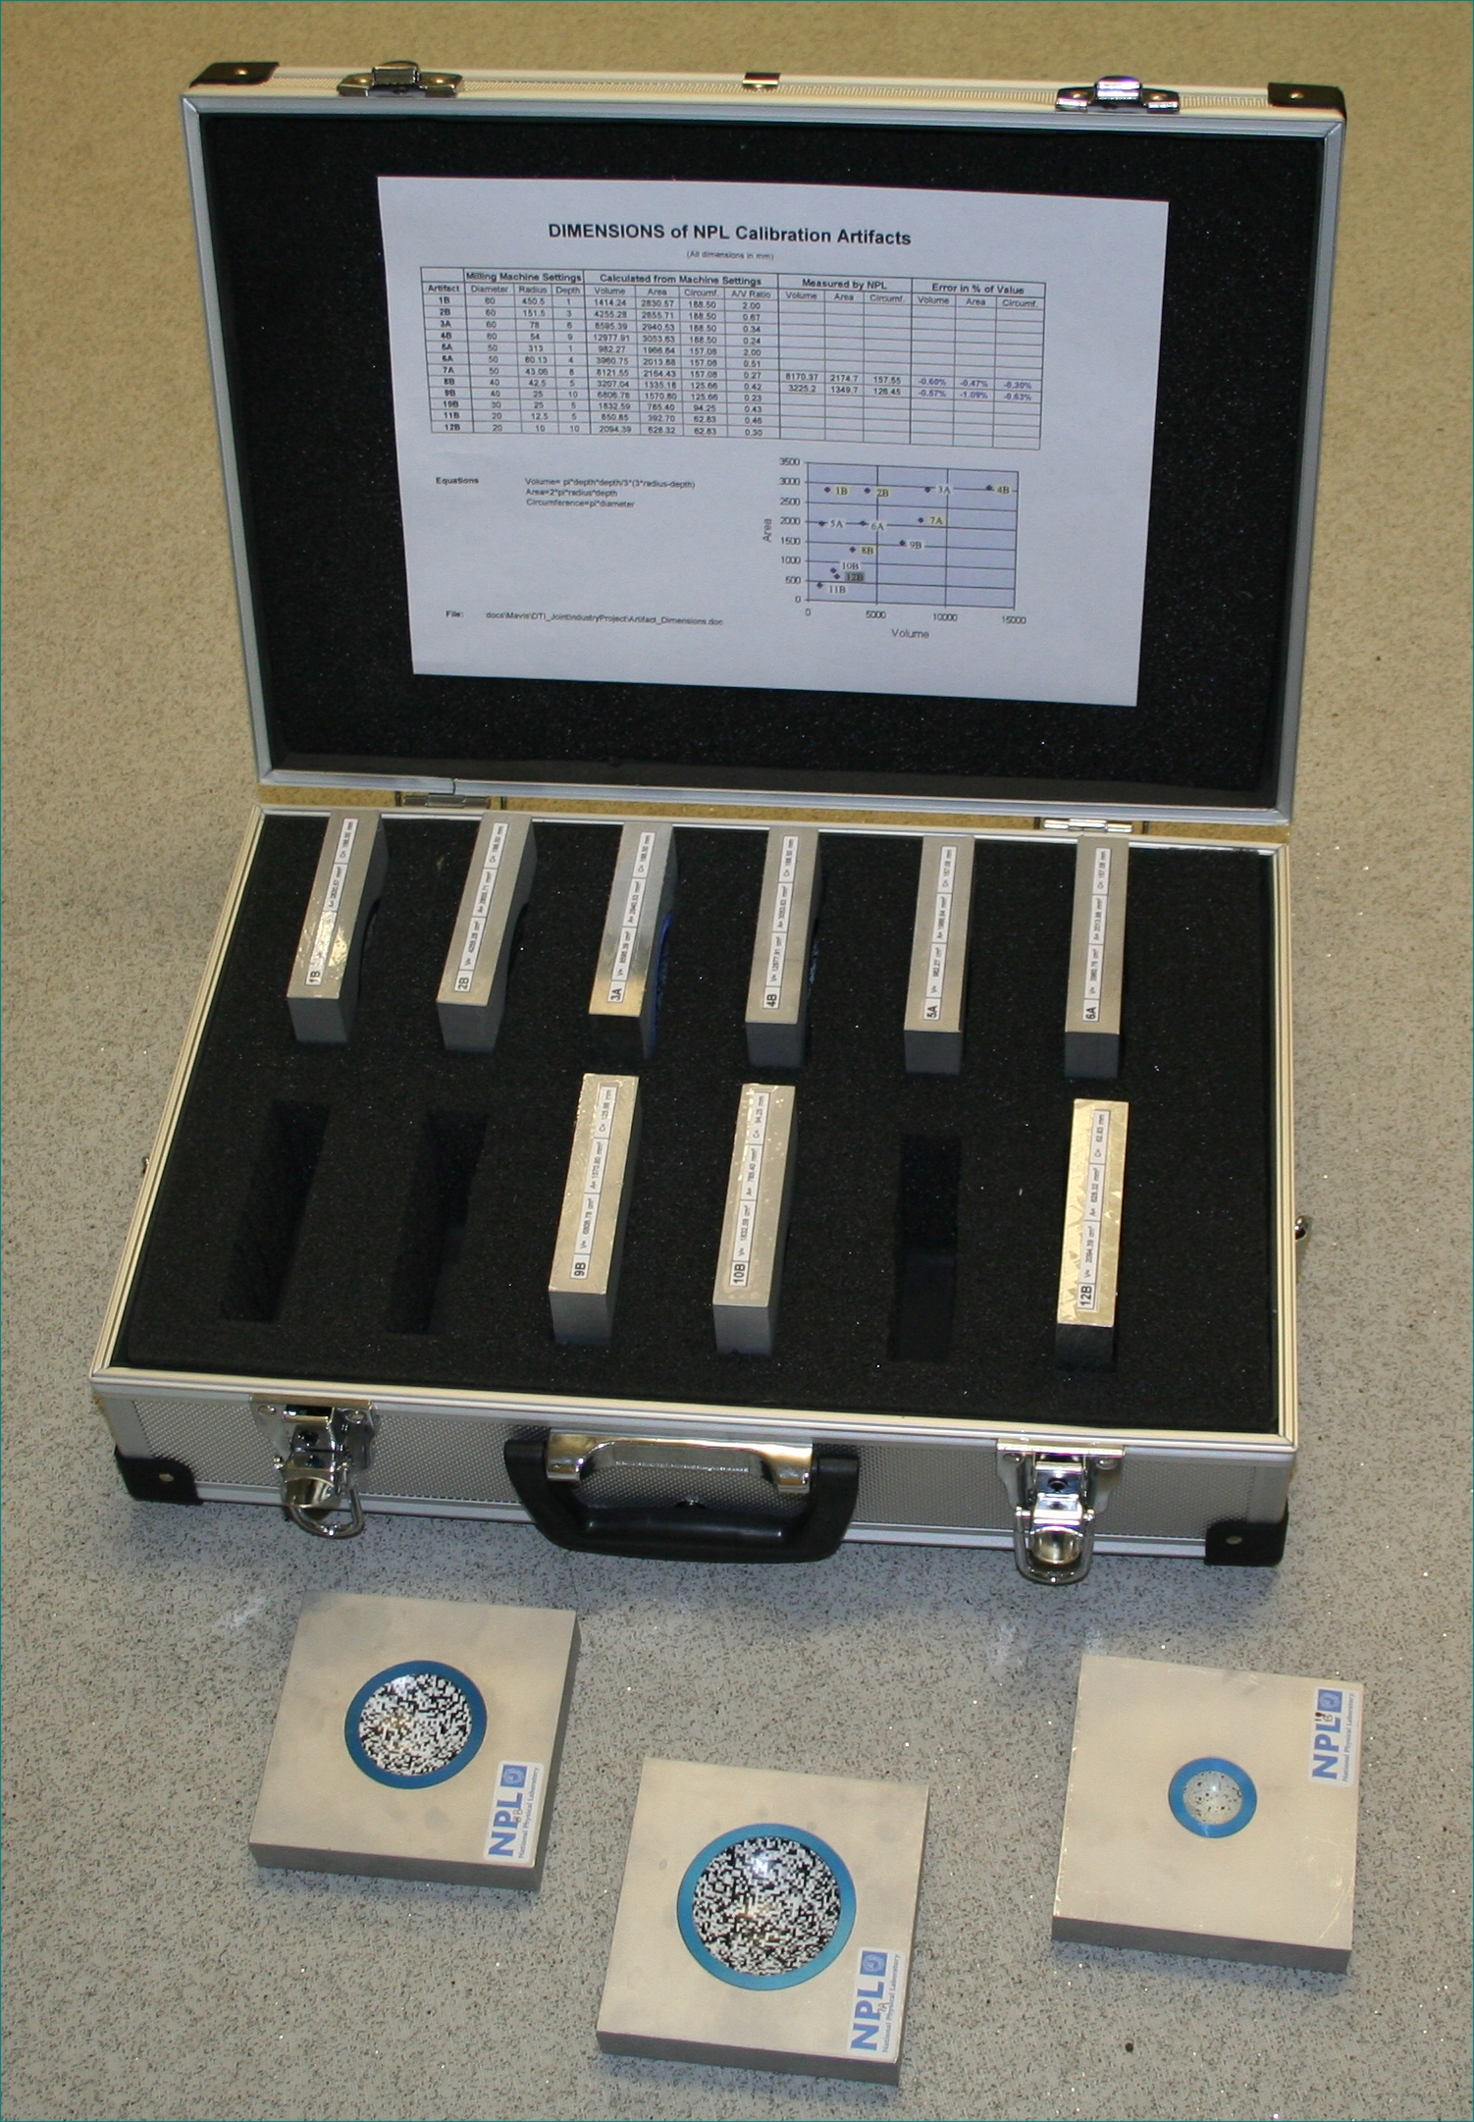

Figure 3: Set of 12 circular calibration artifacts produced and measured by NPL
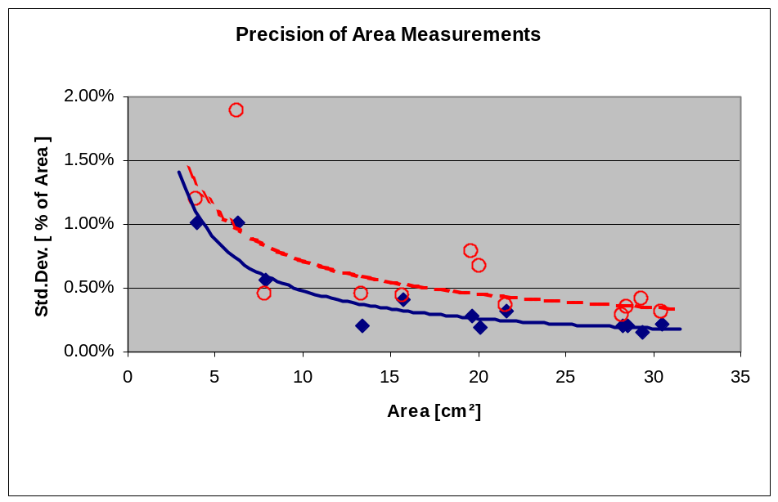
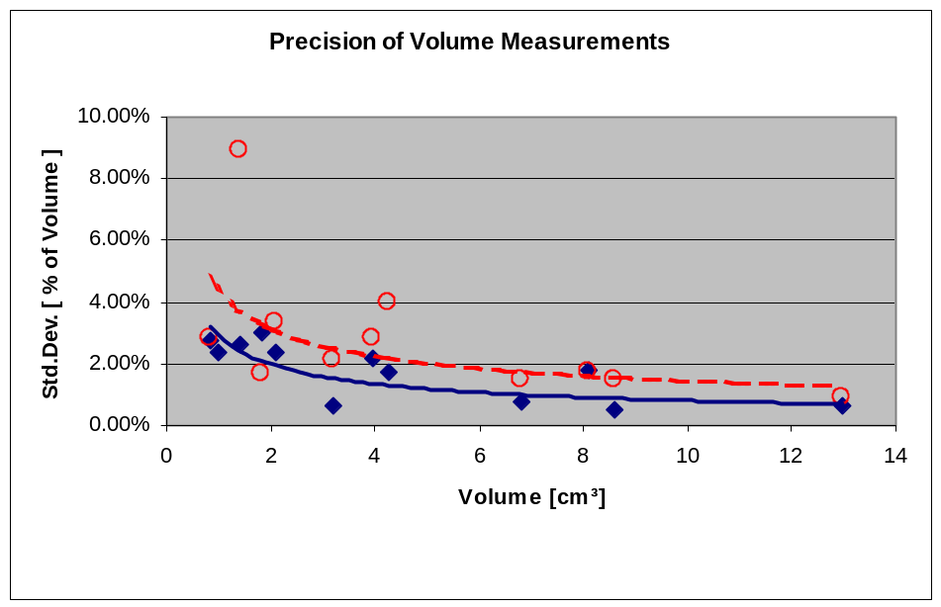
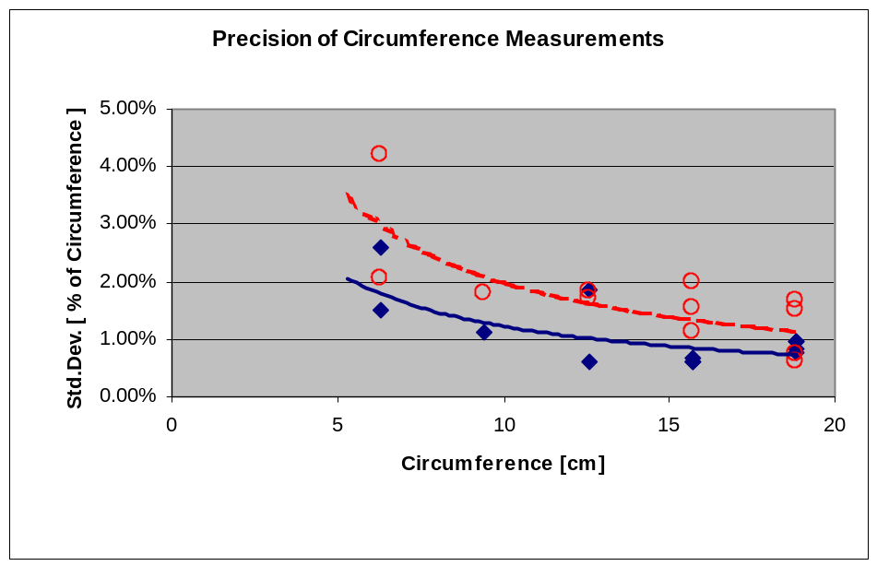
Figure 4: Precision (expressed as 1 standard deviation) of measurements. Diamonds represent the ideal case (laboratory conditions), circles are results of measurements made by untrained volunteers (worst case scenario).
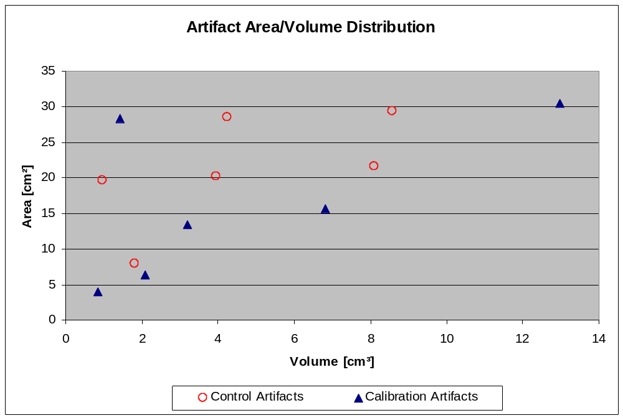
1B
2B
3A
4B
5A
6A
7A
8B
9B
10B
12B
11B
Figure 5: Area and Volume of the 12 calibration artifacts. Dimensions of artifacts used for calibration (triangles) are located on the perimeter of the scatter plot gamut while the control ones (circles) are on the inside.

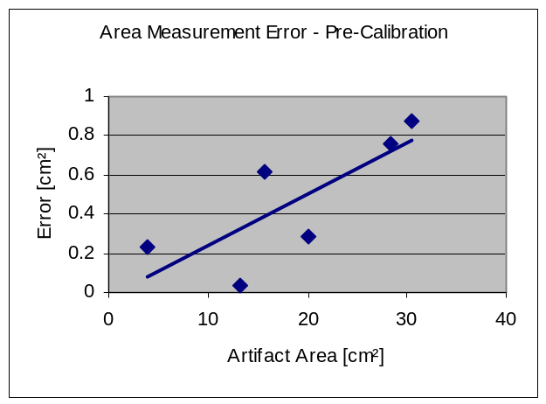
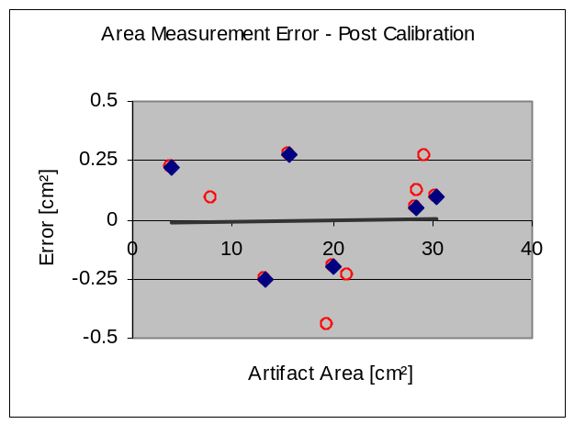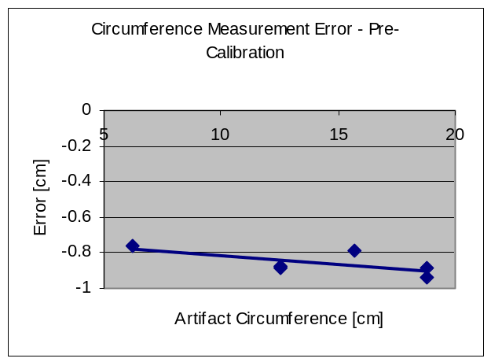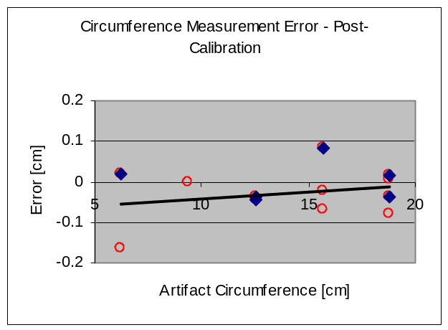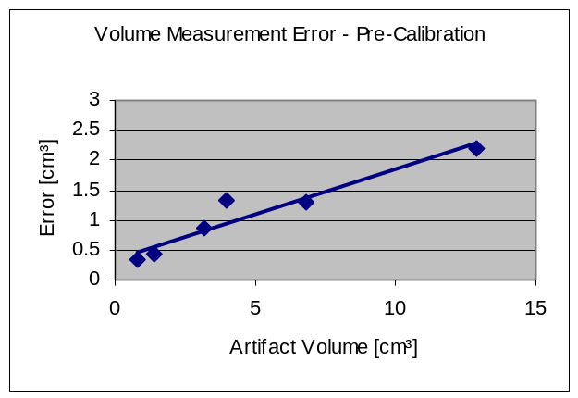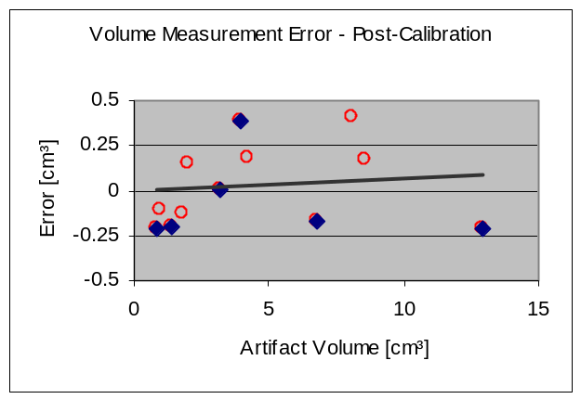
(a) (b)

Figure 6: Accuracy of measurements expressed as the absolute difference between the known artifact dimensions and the mean of measurements. Measurements on the 6 calibration artifacts (diamonds) are shown in the left column (a), measurements on all artifacts (control artifacts represented by circles) after application of correction equations derived from (a) are shown in column (b).

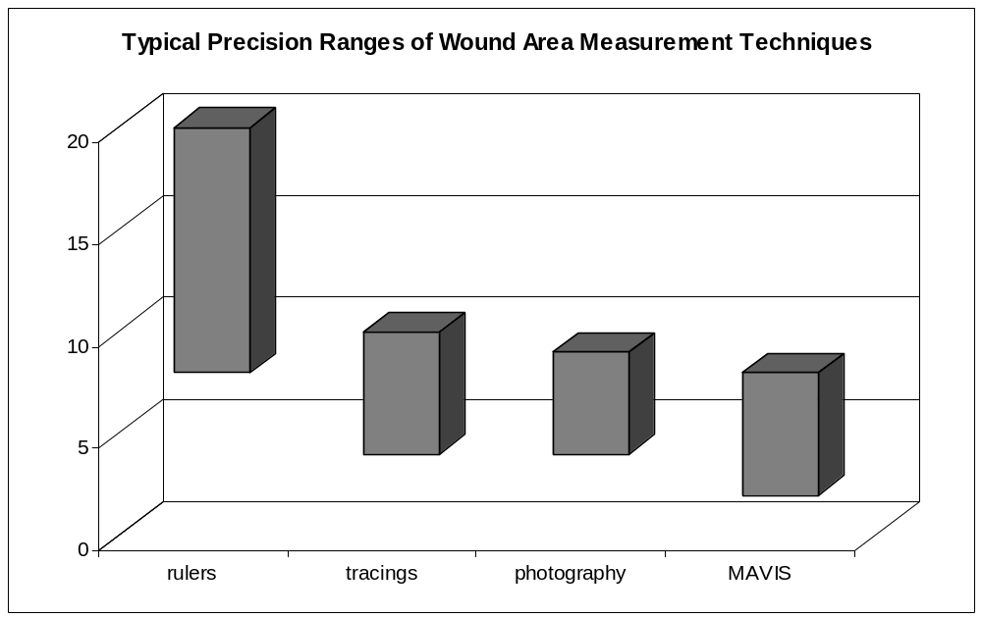
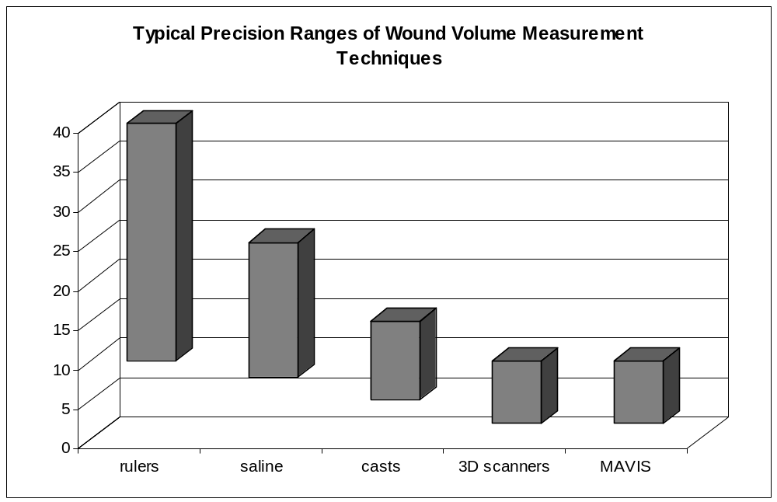

min. precision
(large and shallow wounds)

Figure 7: Typical precision values of wound area and volume measurement techniques quoted in literature compared with MAVIS stereo-photogrammetry device.
max. precision
(small and deep wounds)

